ROBOT RANDOM 4 WORKSTATION RANDOM 645444

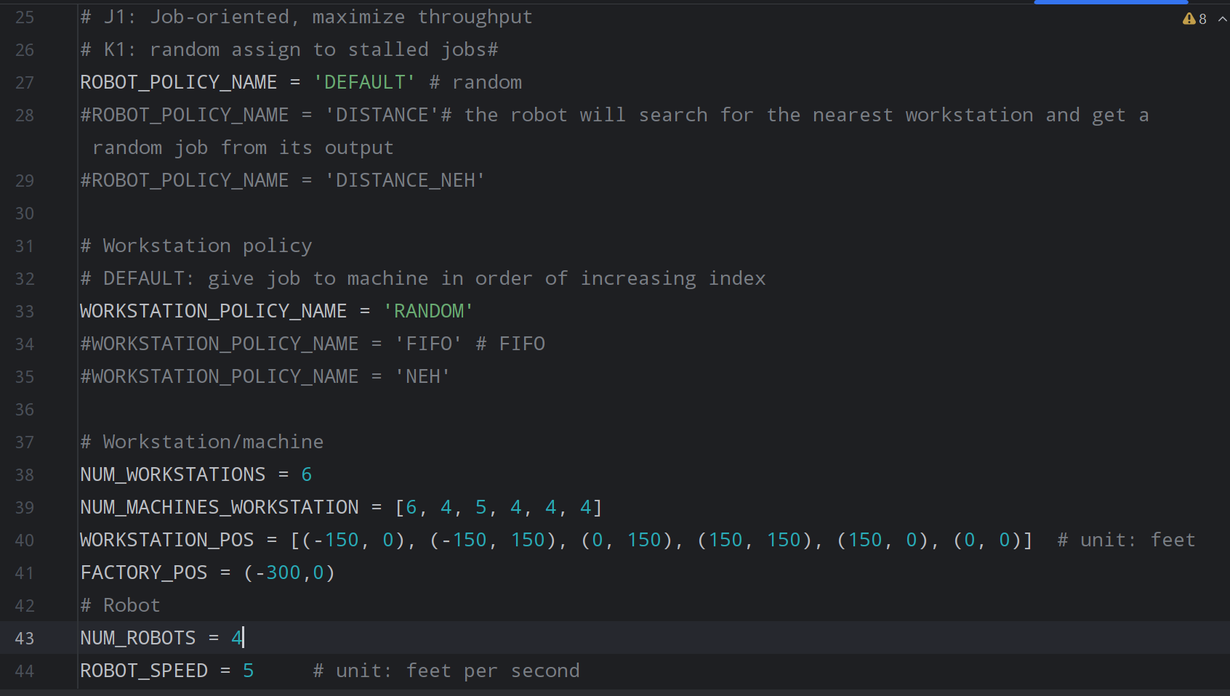

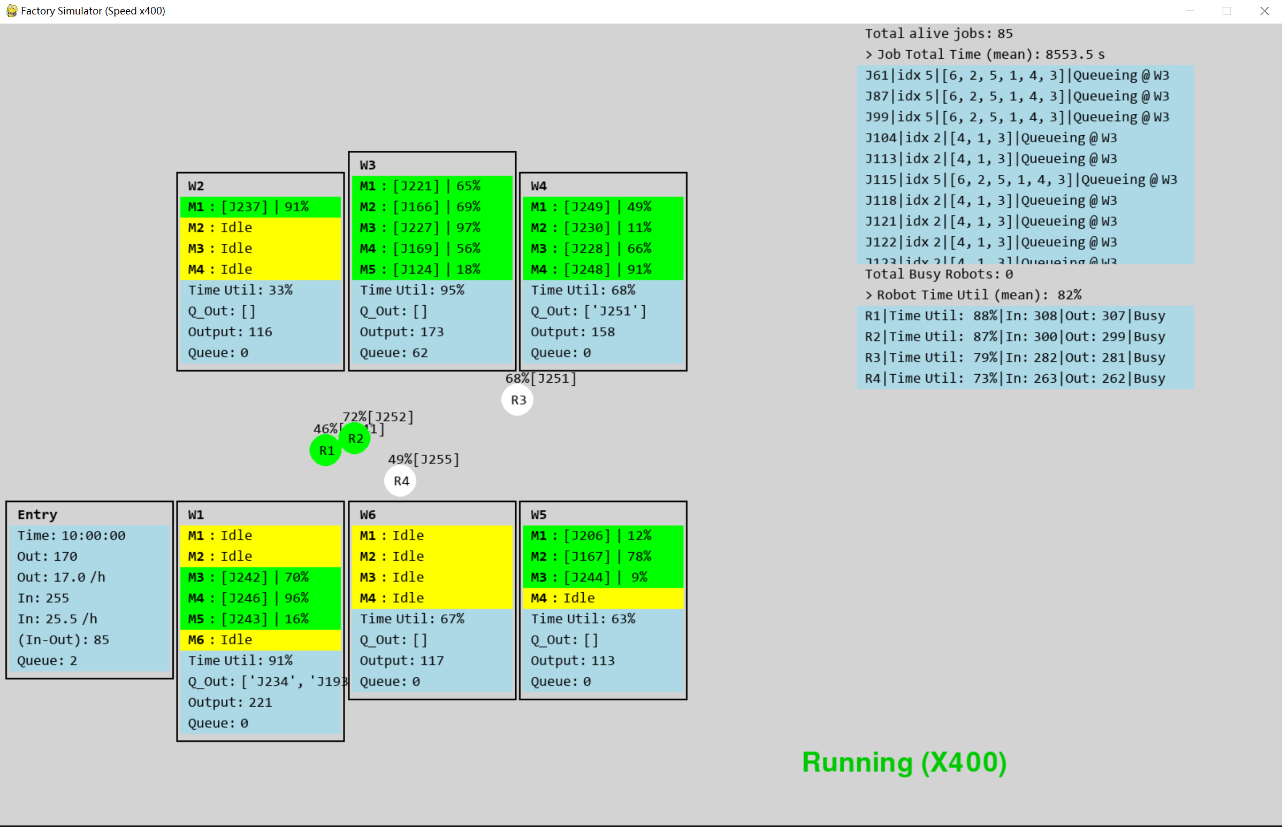

Workstation LQ (Avg Queue Length) WQ (Avg Waiting Time per job)

0 4.481375 632.664706

1 0.022083 3.117647

2 29.803264 4207.519608

3 0.453097 63.966667

4 0.689806 97.384314

5 0.692333 97.741176

**Robot NEH 6 Workstation NEH machine number445444**

Workstation LQ (Avg Queue Length) WQ (Avg Waiting Time per job)

0 59.376278 8382.533333

1 0.014792 2.088235

2 1.945437 274.650000

3 0.290125 40.958824

4 0.829861 117.156863

5 0.461417 65.141176

ROBOT DISTANCE 5 WORKSTATION FIFO 646444

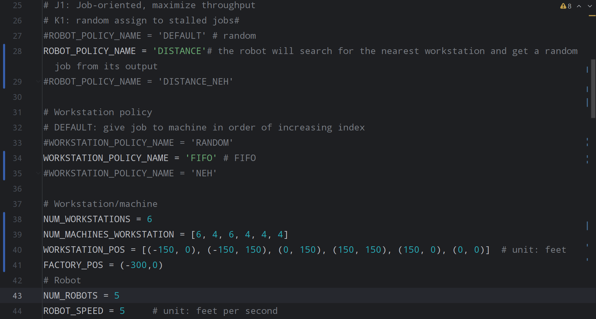

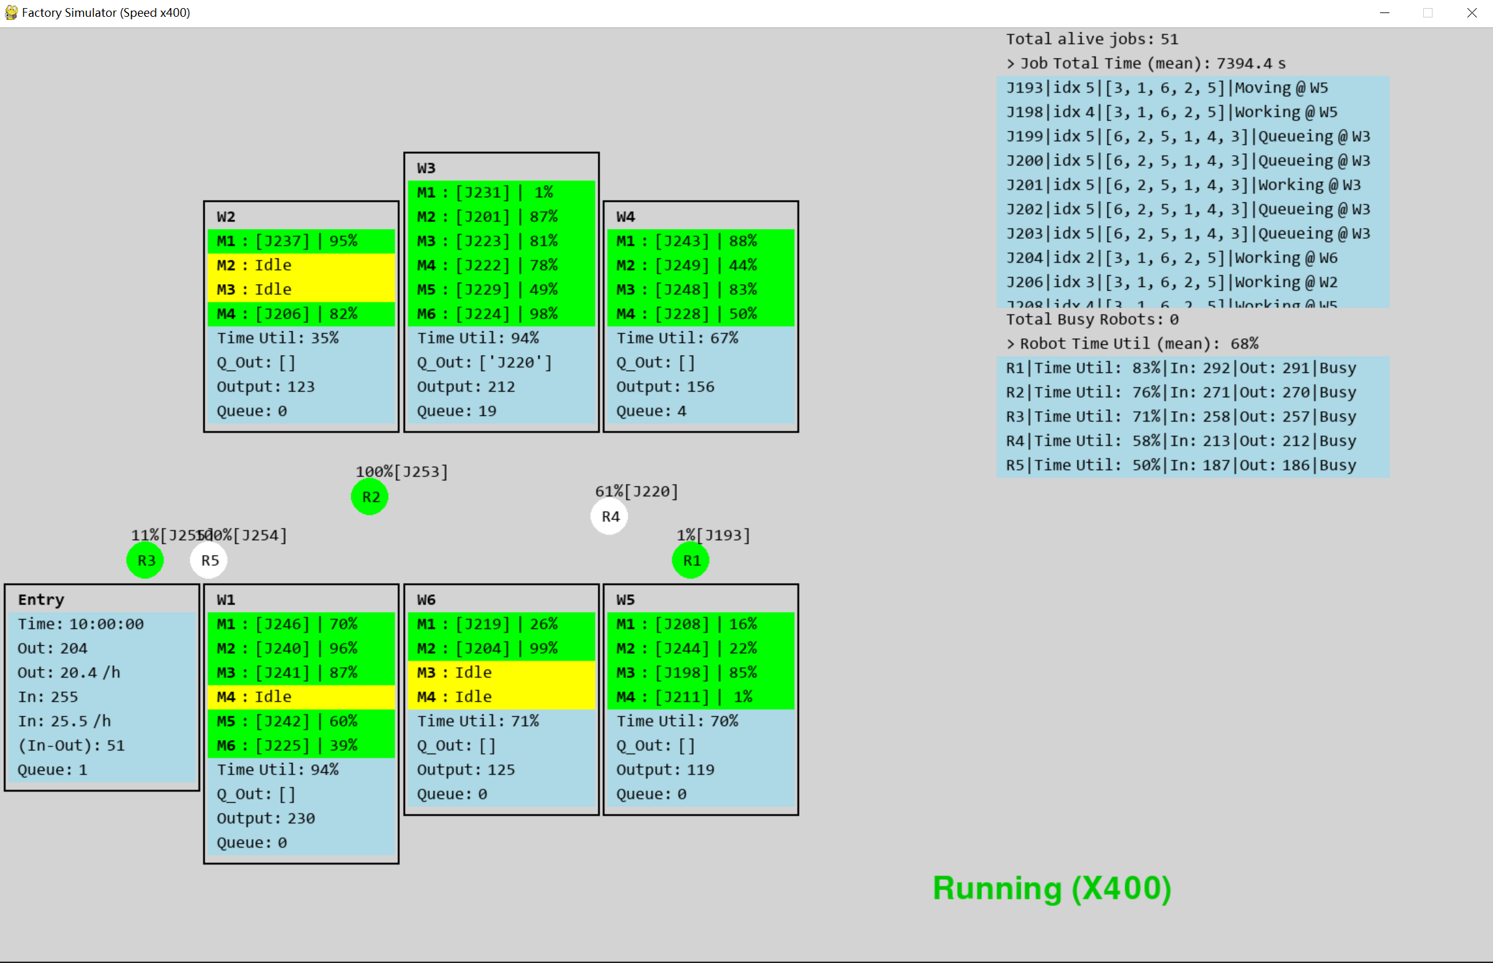

Workstation LQ (Avg Queue Length) WQ (Avg Waiting Time per job)

0 5.645444 797.003922

1 0.033833 4.776471

2 14.570340 2056.989216

3 0.529847 74.801961

4 1.049389 148.149020

5 0.894639 126.301961

40_R_distance_W_fifo_646444

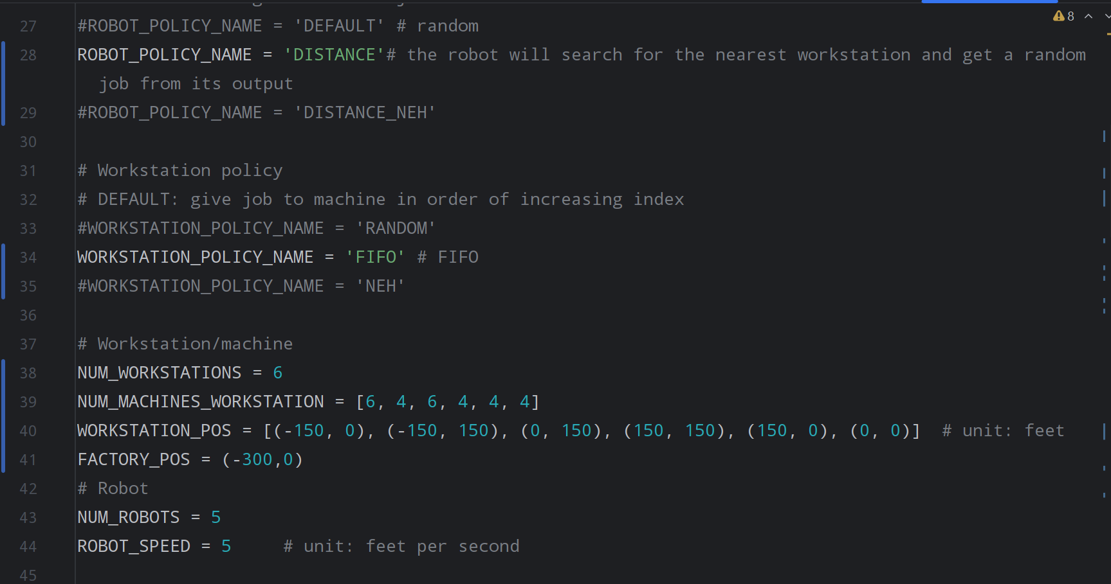

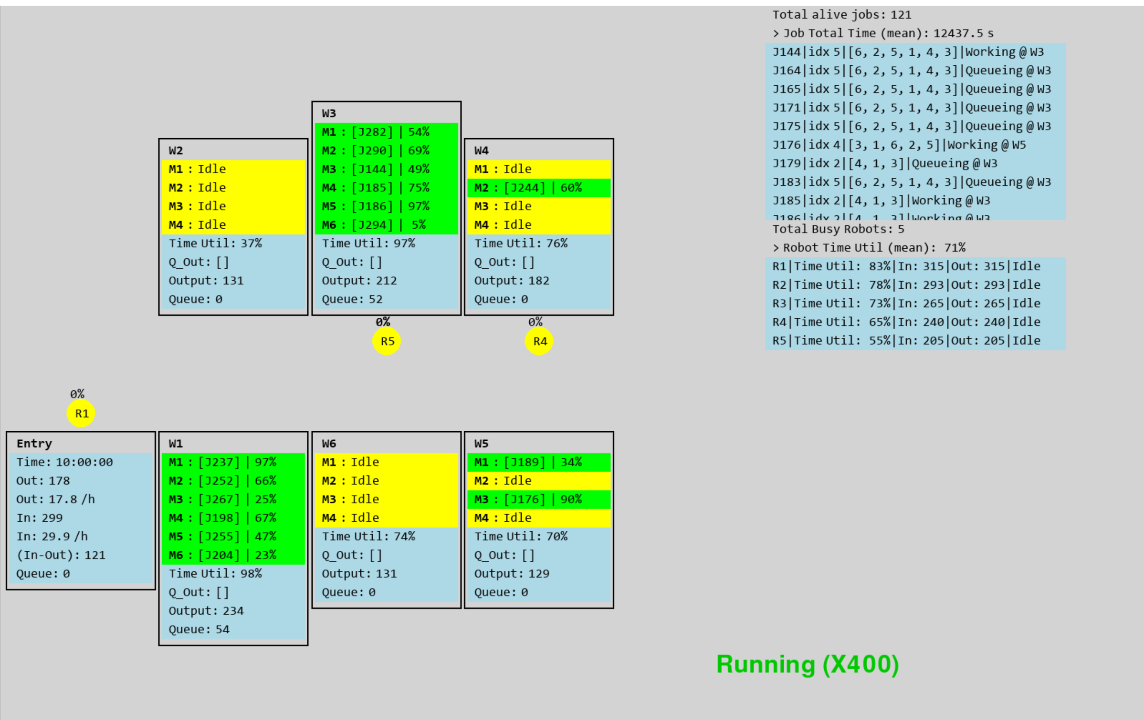

Workstation LQ (Avg Queue Length) WQ (Avg Waiting Time per job)

0 47.868264 6757.872549

1 0.048528 6.850980

2 34.974222 4937.537255

3 1.246625 175.994118

4 0.591069 83.445098

5 1.363472 192.490196

40_R_random_W_random_646444

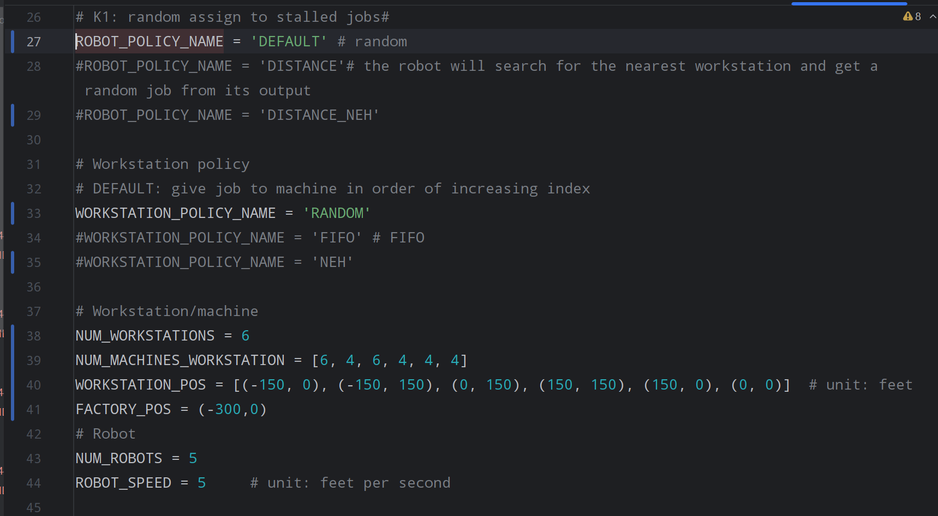

Workstation LQ (Avg Queue Length) WQ (Avg Waiting Time per job)

0 49.958424 7052.953922

1 0.041028 5.792157

2 27.090104 3824.485294

3 1.098778 155.121569

4 2.207750 311.682353

5 1.961389 276.901961